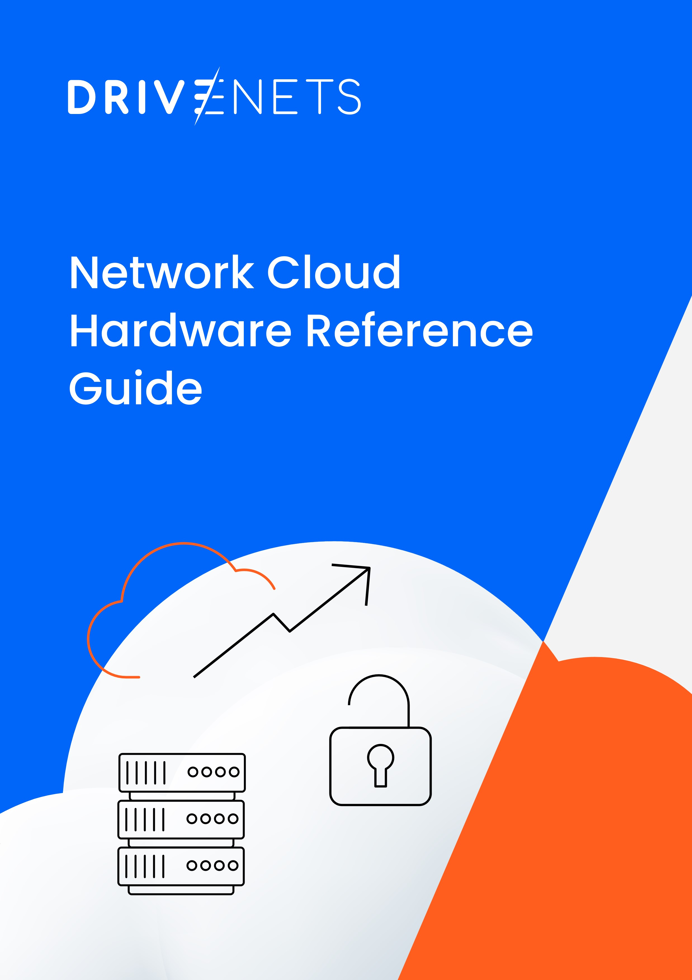

The information contained herein is confidential and proprietary to DriveNets Ltd. In accepting this information, you agree to take all reasonable precautions to prevent any unauthorized use, dissemination, or publication of this information, and further agree to use at least a reasonable degree of care in protecting the confidentiality of this information. No copies of this information are to be made on any type of media, without the prior express written permission of DriveNets. Immediately upon DriveNets’ first request, you will return this information and all copies made thereof.

**Contents**

1. Introduction 2

2. Open Distributed Disaggregated Approach 3

3. Networking-Optimized Hardware 3

4. Cluster Components 4

4.1. NCP: Network Cloud Packet Forwarder 5

4.2. NCF: Network Cloud Fabric 5

4.3. NCM: Network Cloud Management 5

4.4. NCC: Network Cloud Controller 5

5. Known Cluster Topologies 6

6. White Box Certification Process 8

7. Certified White Boxes 8

7.1. NCC: Network Cloud Controller 9

7.2. NCM: Network Cloud Management 10

7.3. NCF: Network Cloud Fabric 11

7.4. NCP: Network Cloud Packet Forwarder 12

7.5. Summary 15

8. Additional Components 16

8.1. Cables and Transceivers 16

8.2. DriveNets Optics and Cables Qualification Process 16

8.3. Supported Optics and Cables 17

# Introduction

The telecommunications industry is constantly seeking networking solutions to balance scalability, innovation, and cost, while also ensuring that the chosen solution is sufficiently adaptable to meet future challenges.

To address this, DriveNets adopted a cloud-computing approach to build networks like cloud. DriveNets Network Cloud is based on network disaggregation, separating hardware from software, and enabling the separation of the data plane from the control plane. The control plane operates on servers, while the data plane is implemented in a cluster of white boxes. The data plane consists of two building blocks: the Network Cloud Packet Forwarder (NCP) and the Network Cloud Fabric (NCF).

From a single stand-alone solution of 4 Tbps, this system can scale up to a massive cluster with a capacity of 691.2 Tbps, and in the near future, even up to 1 Pbps. The cluster itself is constructed using multiple white boxes, which function together as a single routing entity.

Network Cloud’s cloud-native software enables multiple services to run in separate software containers.

Each networking function, which operates as a service instance (SI) microservice within a cloud container, can utilize any underlying hardware resource, such as physical interfaces, NPUs, CPUs, TCAMs, and more.

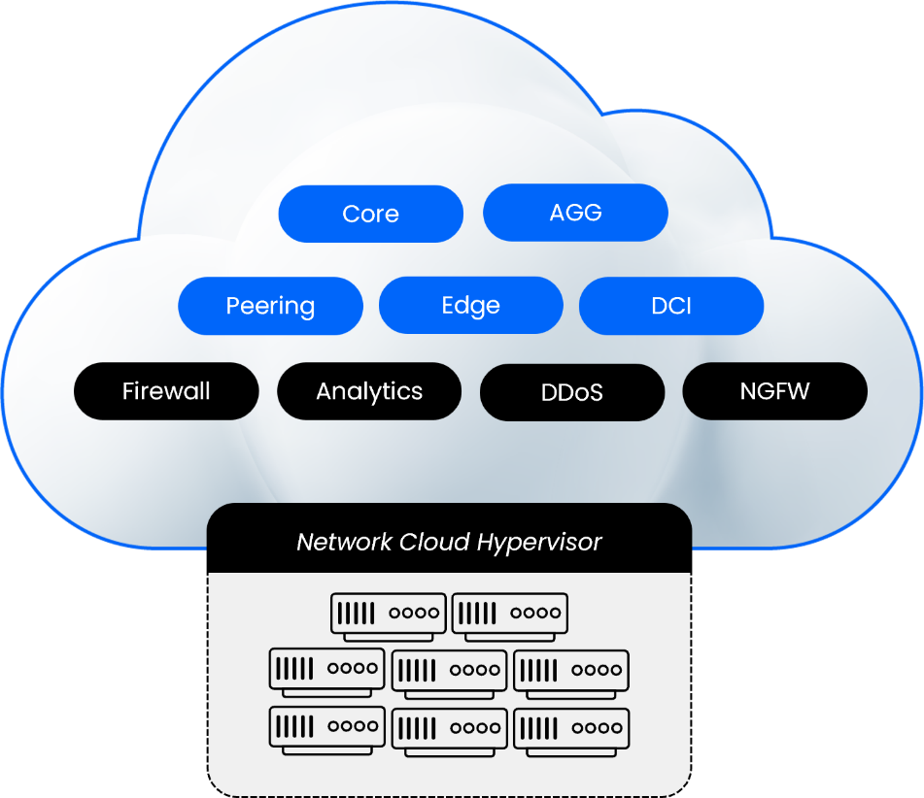

*Figure 1: DriveNets Network Cloud cluster*

DriveNets Network Cloud aims to revolutionize the networking industry in the same way cloud computing transformed on-premises infrastructure – by providing a more flexible, scalable, and cost-effective solution.

# Open Distributed Disaggregated Approach

DriveNet's solution leverages the [OCP DDC standard](https://www.opencompute.org/documents/ocp-hardware-specifications-and-use-case-description-for-j2-ddc-routing-system-pdf) to create networking clusters in various sizes and capacities using standard white boxes running merchant silicon.

At the beginning of 2019, Tier-1 carriers, merchant silicon providers and original design manufacturer (ODM) suppliers submitted specifications for a Distributed Disaggregated Chassis (DDC) architecture to the Open Compute Project (OCP). Using open merchant silicon chips, the DDC design aims to establish a standard set of configurable building blocks to construct service provider-class routers, from single line card systems to large, disaggregated chassis clusters.

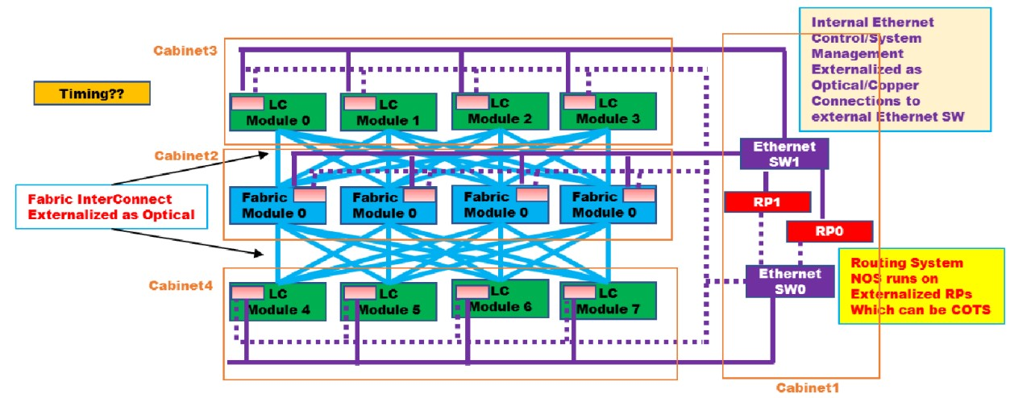

*Source:* [*OCP DDC spec*](https://www.opencompute.org/documents/ocp-hardware-specifications-and-use-case-description-for-j2-ddc-routing-system-pdf)

*Figure 2: OCP's initial concept design of DDC Routing System*

This architecture is designed from the ground up to meet the rigid requirements of carrier networks and provides end-to-end functionality for core, edge, peering, and access locations. In a DDC-RS (Distributed Disaggregated Chassis Routing System), the functional components are redistributed differently than in traditional chassis-based solutions. The router is a collection of physical boxes connected in CLOS architecture and the software is based on virtualized or containerized functions.

The figures above shows a high-level design of both the OCP's and DriveNets’ DDC-RS. The DDC architecture eliminates physical boundaries, enabling the addition of virtually unlimited new white boxes, providing very high scalability and inherent redundancy.

# Networking-Optimized Hardware

DriveNets software is designed to be hardware-agnostic, but it requires underlying hardware to conform to open standards. Therefore, the company has contributed significantly to the open networking community. By combining networking-optimized hardware with open standards alignment, DriveNets can ensure optimal performance while maintaining an open and disaggregated system.

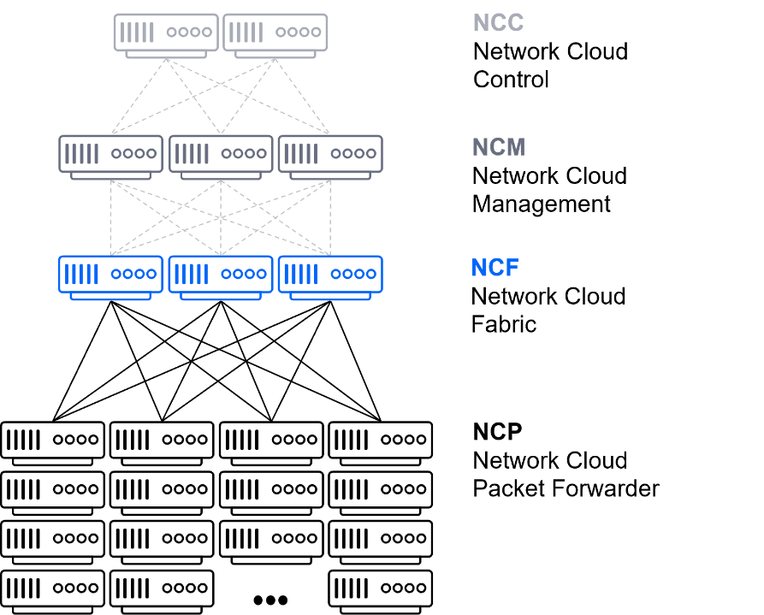

*Figure 3: DriveNets DDC*

Using general-purpose CPUs (x86) to construct a large-scale networking function is not cost-effective, especially for carrier-grade networking solutions. As a result, DriveNets utilizes networking-optimized hardware. However, shifting to application-specific integrated circuits (ASICs) typically requires interacting with the Switch Abstraction Interface (SAI), which lacks critical features for service providers since it was originally designed for data centers and enterprise networks.

To overcome this challenge, DriveNets collaborated closely with Broadcom, the leading silicon manufacturer, and utilized dedicated hardware that adheres to OCP specifications. This enables DriveNets to provide its optimized DriveNets Network Operating System (DNOS) and a hardware blueprint that is highly agnostic to certified ODM vendors.

# Cluster Components

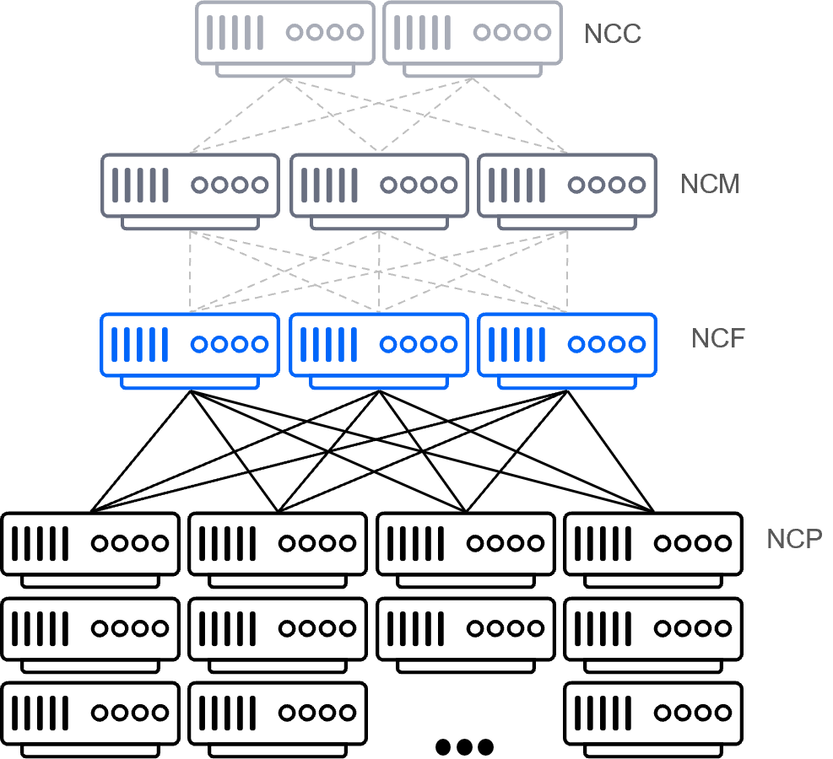DriveNets Network Cloud supports two models – stand-alone or cluster – both of which are built on standard white boxes using merchant silicon. The stand-alone model, as its name suggests, uses a single white box to build a routing function. The cluster model uses multiple white boxes orchestrated to form a comprehensive network element, with cluster sizes ranging from 4 Tbps up to 691.2 Tbps. All clusters comprise multiple elements, including:

* NCP: Network Cloud Packet Forwarder
* NCF: Network Cloud Fabric
* NCM: Network Cloud Management
* NCC: Network Cloud Controller

*Figure 4 = DriveNets cluster components*

## NCP: Network Cloud Packet Forwarder

The NCP is a carrier-grade, high-rate forwarding element responsible for datapath traffic forwarding. The NCP can be deployed as part of a cluster or as a stand-alone device. NCP main features:

* Packet processing and forwarding based on the forwarding information base (FIB) tables
* Access control based on access control lists (ACLs)
* Quality of service (QoS) classification
* Bidirectional Forwarding Detection (BFD)
* The NCP standard white box is supplied by various ODMs and is OCP DDC-compliant. (See the Certified White Boxes section below for already certified elements.)

## NCF: Network Cloud Fabric

The NCF provides the non-blocking bandwidth to switch traffic from one NCP to another. NCFs are connected via internal optical interfaces and packets are spread across the links to fully utilize fabric capacity. In a stand-alone deployment, the NCF is not required. NCF main features:

* Intra-cluster datapath connectivity between NCPs in a cluster
* Connectivity from any port to any other port in the virtual chassis structure
* Interconnection to all NCPs in a non-blocking manner regardless of traffic size
* All fabric modules in the cluster are active-active, with precalculated port redundancy

The NCF standard white box is supplied by various ODMs and is OCP DDC-compliant. (See the Certified White Boxes section below for already certified elements.)

## NCM: Network Cloud Management

The NCM enables the management of communication within the cluster. NCM main features:

* Aggregate management traffic from all rack elements – NCPs, NCFs and NCCs
* Enables cluster management communication

The total number of NCM switches required per cluster depends on the cluster’s size, namely on the number of NCPs and NCFs.

## NCC: Network Cloud Controller

The NCC is a software element that handles all control (routing stack) and management paths (internal and external). NCC main features:

* Supporting and managing the routing protocols and tables for the clusters, maintaining the routing information base (RIB), and updating the forwarding information base (FIB) on the NCPs
* Supporting all management services, daemons, and northbound interfaces, including command-line interfaces (CLIs), statistics, and fault alerts management from the NCPs and other network elements

In a cluster mode, the NCC is installed on an x86 server as a dedicated Docker container that can run in a redundancy pair scheme (1+1). In a stand-alone deployment, the NCC is installed on the NCP.

# Known Cluster Topologies

DriveNets Network Cloud networking clusters can be of various sizes and capacities using standard white boxes running merchant silicon. Service providers can build core, edge, peering, and access locations using a stand-alone box or a cluster of dozens of white boxes that can stretch from 2.4 Tbps up to 691.2 Tbps, and in the near future even up to 1 Pbps.

The figure below shows the common spread of various cluster topologies:

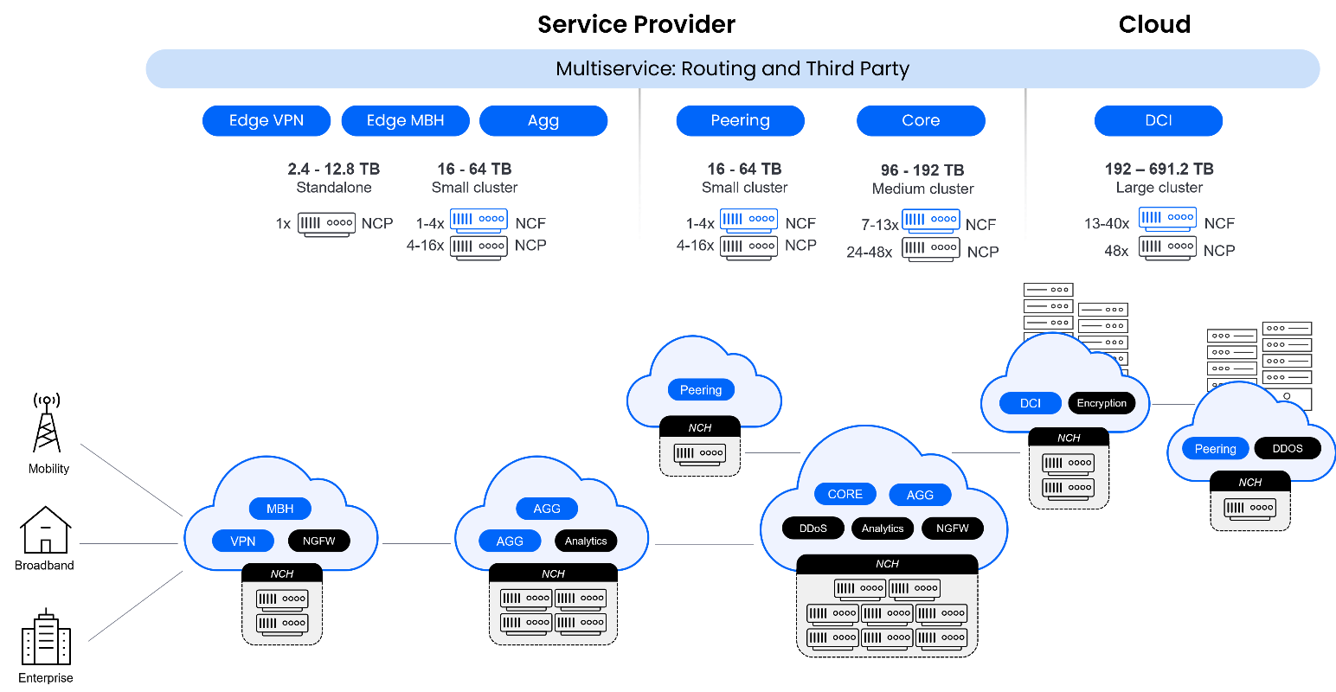

*Figure 5: Core, edge, peering, and access solutions using the same white boxes.*

Below are the primary cluster topologies that use white boxes based on Broadcom Jericho2. However, additional customer-defined topologies can also be deployed, if necessary:

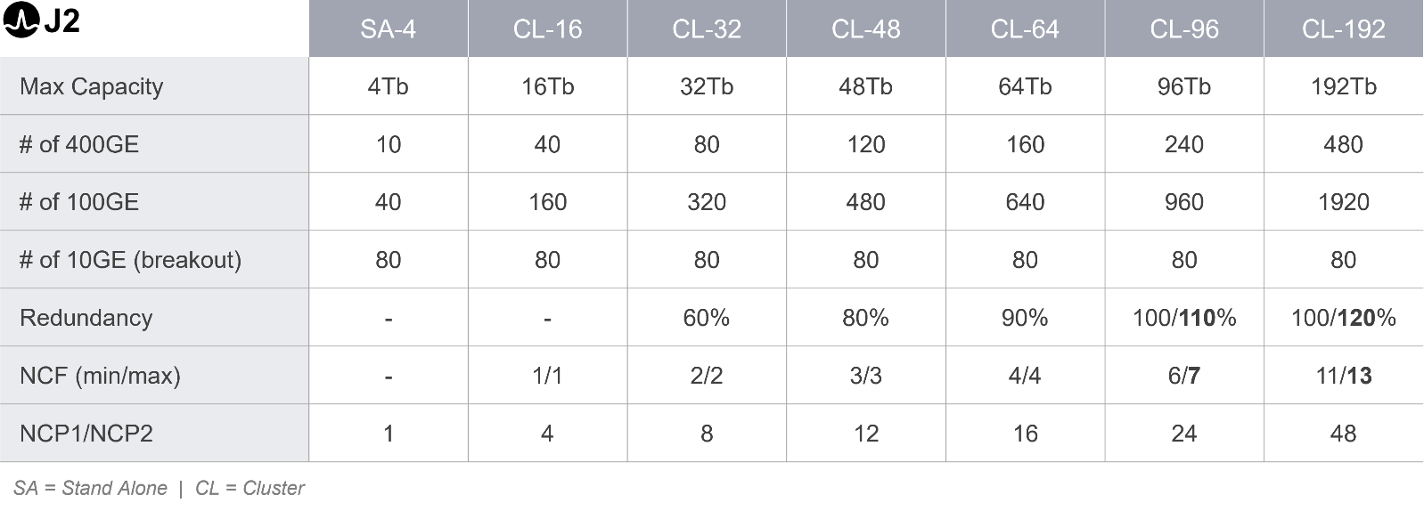

Below are the primary cluster topologies that use white boxes based on Broadcom Jericho J2c+. However, additional customer-defined topologies can also be deployed, if necessary:

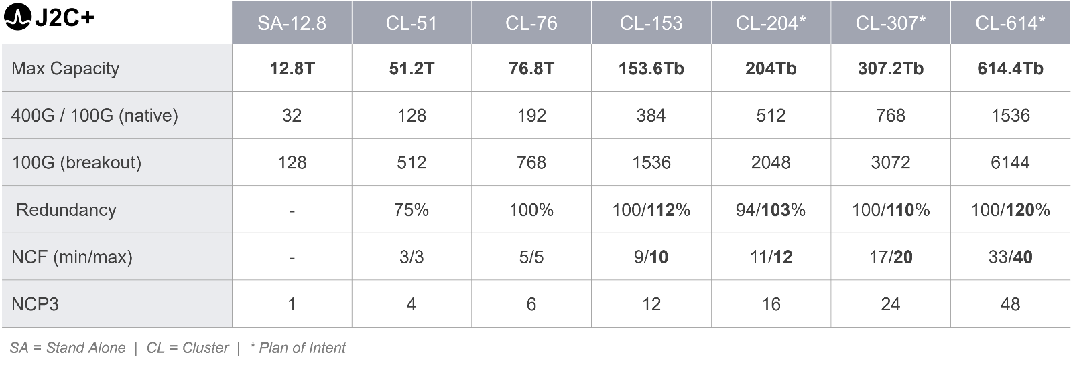

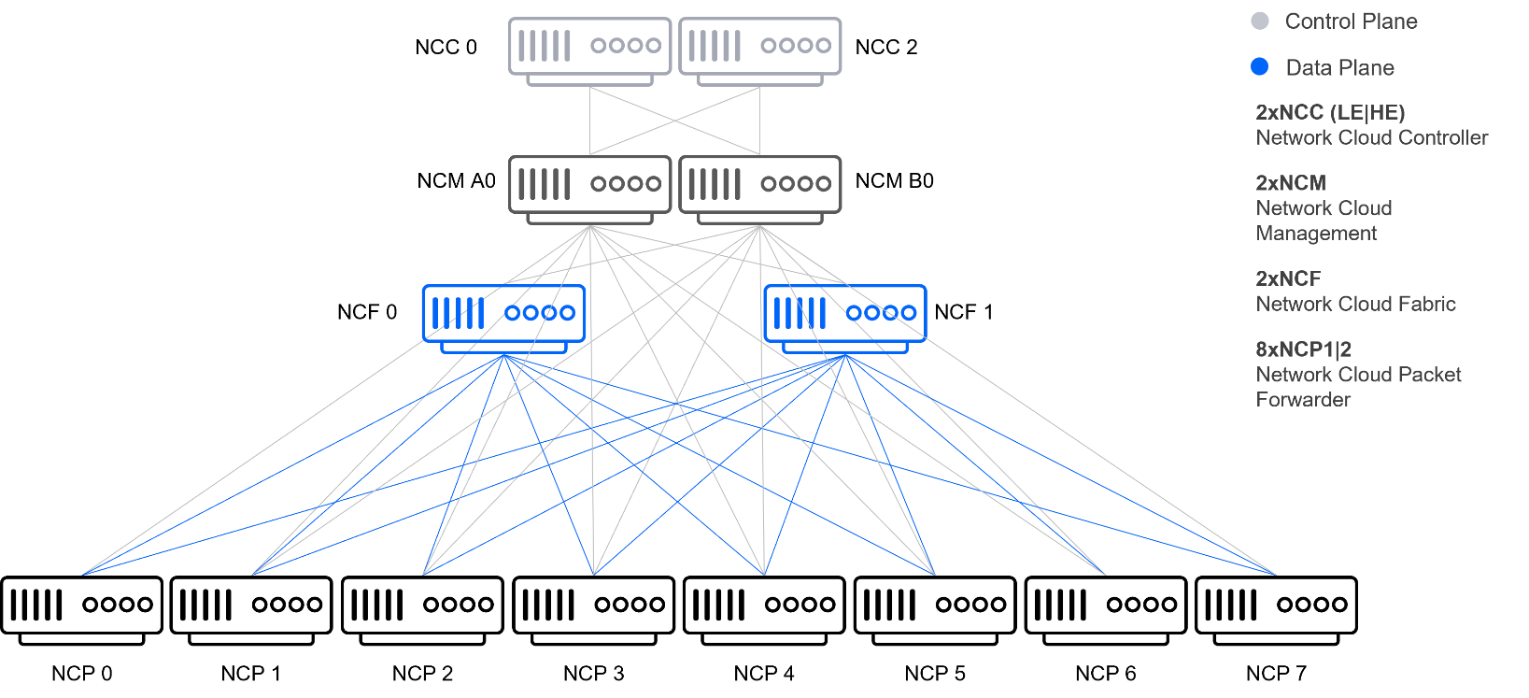

*Figure 6: CL-32 complete cluster architecture*

### Hybrid Cluster

DriveNets Network Cloud empowers cloud service providers to build a versatile hybrid cluster. This means creating a cluster with a diverse range of interfaces, from 1G all the way up to 400G, with plans to introduce 800G interfaces soon. The hybrid cluster architecture offers unparalleled flexibility, allowing for the seamless integration of multi-router software that operates independently within the same cluster. This approach enables the use of any interface between 1G and 800G, making it possible to operate a core router with 400G and 100G interfaces alongside an edge router with 1G and 10G interfaces. This unique scenario creates a shared resource cluster while allowing both routers to remain fully autonomous.

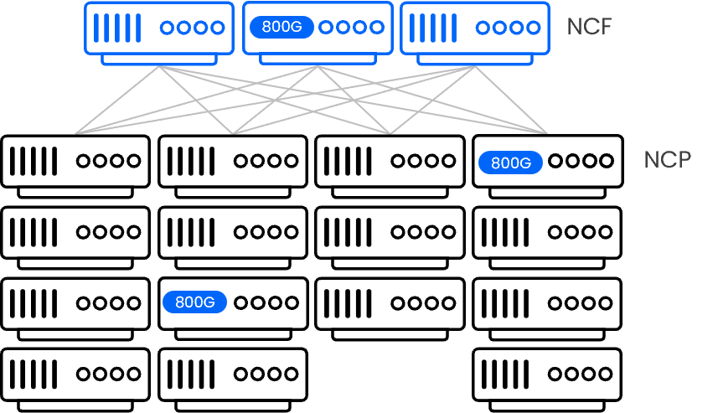

*Figure 7: Hybrid multi-generation cluste*

To future-proof the cluster, DriveNets also supports white boxes from multiple generations. For instance, white boxes utilizing different Broadcom ASICs (J2, J2c+, J2c) can be deployed on the same cluster.

# White Box Certification Process

The white box certification process is a crucial step in ensuring that DriveNets’ main hardware building blocks meet certain quality and performance standards. This process involves an evaluation of the hardware’s design, functionality, and interoperability with other devices and software. The process is designed to be simple and transparent, while ensuring that customers build their network with reliable and compatible equipment that meets their specific networking needs.



Certification process stages:

* **ODM selection:** selecting an original design manufacturer
* **Requirements and Analysis:** reviewing requirements and specifications for the board design with the ODM
* **Conceptual and Layout Design:** developing a high-level design and layout that meets requirements and specifications
* **Firmware Testing:** testing the prototype board with DNOS firmware to ensure compliance with requirements and specifications – first as a stand-alone device and then as part of a larger cluster
* **Final Product Fabrication and Testing:** fabricating the final product, incorporating changes, and testing the final product

# Certified White Boxes

The following white boxes already have gone through DriveNet’s certification process (as described in section 6 above) to ensure that they meet DriveNets’ requirements and specifications in terms of security, functionality, interoperability, and reliability.

## NCC: Network Cloud Controller

The NCC is a software element that manages all control and management paths, both internal and external, through the routing stack. It is installed on an x86 machine and utilizes ethernet adapter cards to connect with other components within the cluster.

#### NCC Hardware Design

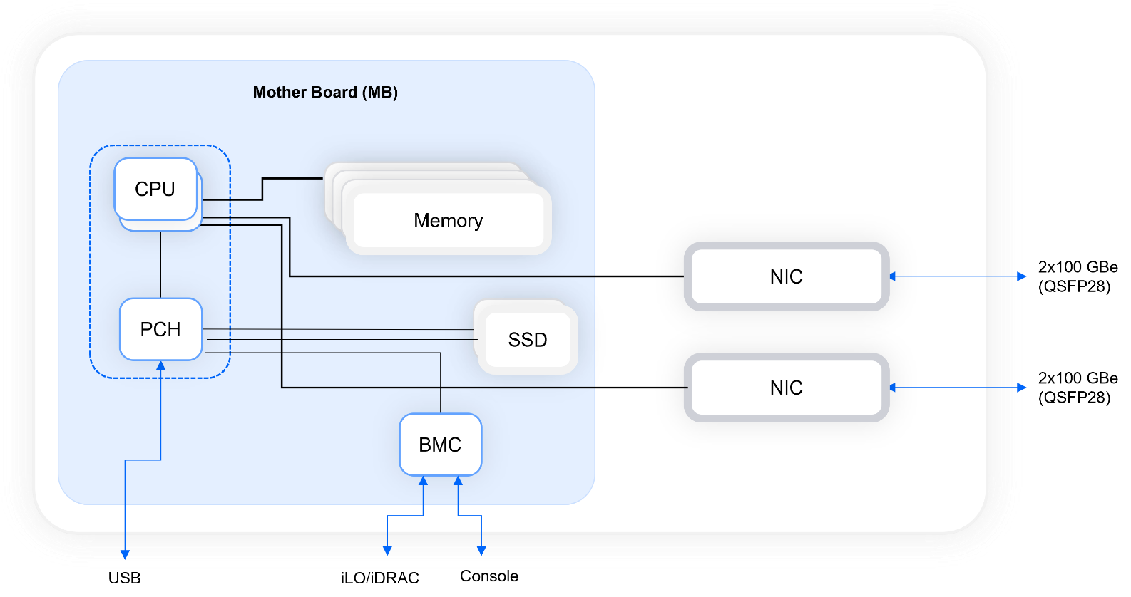

**NCC Hardware Variations**

**Network Cloud Controller (NCC)**

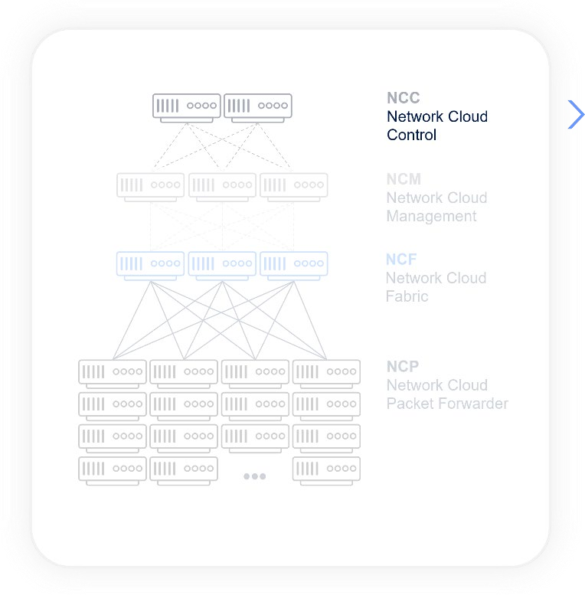

*HPE ProLiant DL380*

*Gen10 Server*

[e](https://buy.hpe.com/us/en/compute/rack-servers/proliant-dl300-servers/proliant-dl380-server/hpe-proliant-dl380-gen10-server/p/1010026818)

[Link to manufacturer Sit](https://buy.hpe.com/us/en/compute/rack-servers/proliant-dl300-servers/proliant-dl380-server/hpe-proliant-dl380-gen10-server/p/1010026818)

*Dell EMC POWEREDGE R640*

*Dell EMC POWERED*

*GE R740*

[Link to](https://www.dell.com/en-us/shop/dell-poweredge-servers/poweredge-r640-rack-server/spd/poweredge-r640/pe_r640_tm_vi_vp_sb)

[r](https://www.dell.com/en-us/shop/dell-poweredge-servers/poweredge-r640-rack-server/spd/poweredge-r640/pe_r640_tm_vi_vp_sb)

[manufacture](https://www.dell.com/en-us/shop/dell-poweredge-servers/poweredge-r640-rack-server/spd/poweredge-r640/pe_r640_tm_vi_vp_sb)

[Sit](https://www.dell.com/en-us/shop/dell-poweredge-servers/poweredge-r640-rack-server/spd/poweredge-r640/pe_r640_tm_vi_vp_sb)

[e](https://www.dell.com/en-us/shop/dell-poweredge-servers/poweredge-r640-rack-server/spd/poweredge-r640/pe_r640_tm_vi_vp_sb)

[Lin](https://www.dell.com/en-us/shop/dell-poweredge-servers/poweredge-r740-rack-server/spd/poweredge-r740/pe_r740_tm_vi_vp_sb)

[k](https://www.dell.com/en-us/shop/dell-poweredge-servers/poweredge-r740-rack-server/spd/poweredge-r740/pe_r740_tm_vi_vp_sb)

[to manufacturer Sit](https://www.dell.com/en-us/shop/dell-poweredge-servers/poweredge-r740-rack-server/spd/poweredge-r740/pe_r740_tm_vi_vp_sb)

[e](https://www.dell.com/en-us/shop/dell-poweredge-servers/poweredge-r740-rack-server/spd/poweredge-r740/pe_r740_tm_vi_vp_sb)

*NVIDIA Mellanox ConnectX*

*-*

*5*

*HPE InfiniBand*

*EDR/Ethernet Adapter*

[k](https://www.nvidia.com/en-us/networking/ethernet/connectx-5/)

[Lin](https://www.nvidia.com/en-us/networking/ethernet/connectx-5/)

[to](https://www.nvidia.com/en-us/networking/ethernet/connectx-5/)

[r](https://www.nvidia.com/en-us/networking/ethernet/connectx-5/)

[manufacture](https://www.nvidia.com/en-us/networking/ethernet/connectx-5/)

[Sit](https://www.nvidia.com/en-us/networking/ethernet/connectx-5/)

[e](https://www.nvidia.com/en-us/networking/ethernet/connectx-5/)

[k](https://buy.hpe.com/us/en/options/adapters/host-adapters/proliant-host-adapters/hpe-infiniband-edr-ethernet-100gb-2-port-841qsfp28-adapter/p/872726-b21)

[Lin](https://buy.hpe.com/us/en/options/adapters/host-adapters/proliant-host-adapters/hpe-infiniband-edr-ethernet-100gb-2-port-841qsfp28-adapter/p/872726-b21)

[to manufacturer Sit](https://buy.hpe.com/us/en/options/adapters/host-adapters/proliant-host-adapters/hpe-infiniband-edr-ethernet-100gb-2-port-841qsfp28-adapter/p/872726-b21)

[e](https://buy.hpe.com/us/en/options/adapters/host-adapters/proliant-host-adapters/hpe-infiniband-edr-ethernet-100gb-2-port-841qsfp28-adapter/p/872726-b21)

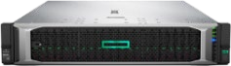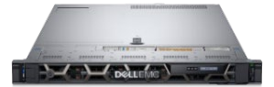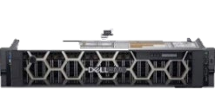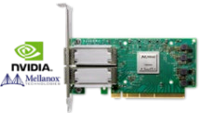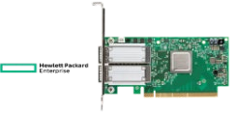

*HPE ProLiant*

*DL360*

*Gen10 Server*

[e](https://buy.hpe.com/us/en/servers/proliant-dl-servers/proliant-dl300-servers/proliant-dl360-server/hpe-proliant-dl360-gen10-server/p/1010007891)

[Link to manufacturer Sit](https://buy.hpe.com/us/en/servers/proliant-dl-servers/proliant-dl300-servers/proliant-dl360-server/hpe-proliant-dl360-gen10-server/p/1010007891)

## NCM: Network Cloud Management

As stated previously, the NCM enables the management of communication within the cluster. **NCM Hardware Design**

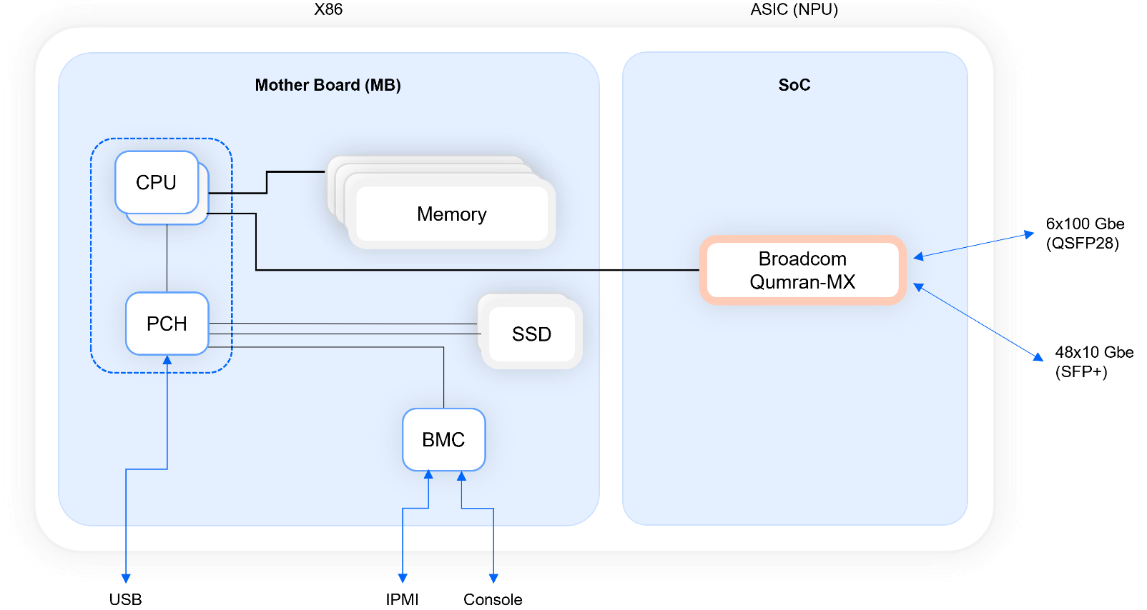

#### NCM Hardware



**Network Cloud Management (NCM)**

*Aggregation router*

*48*

*x 1G/10G SFP+, 6 x 100G QSFP28 with*

*Qumran MX*

*DN model: NCM*

*-*

*48*

*X*

*-*

*6*

*C Edgecore*

*model:*

[Link to manufacturer site](https://www.edge-core.com/productsInfo.php?cls=291&cls2=327&cls3=328&id=771)

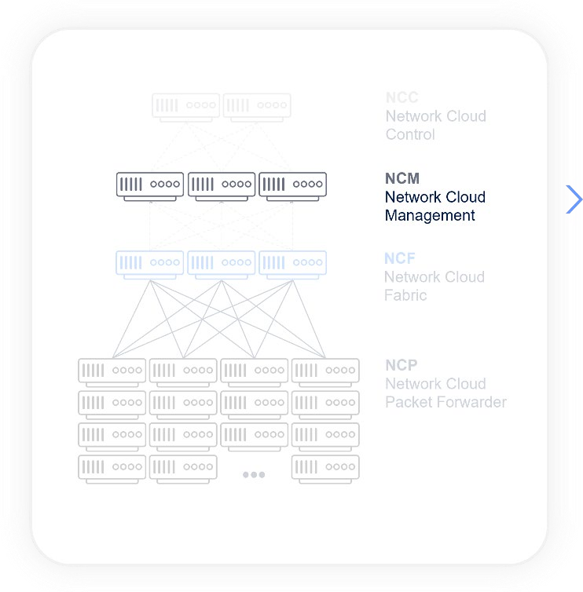

## NCF: Network Cloud Fabric

The NCF provides the non-blocking bandwidth to switch traffic from one NCP to another. **NCF Hardware Design**

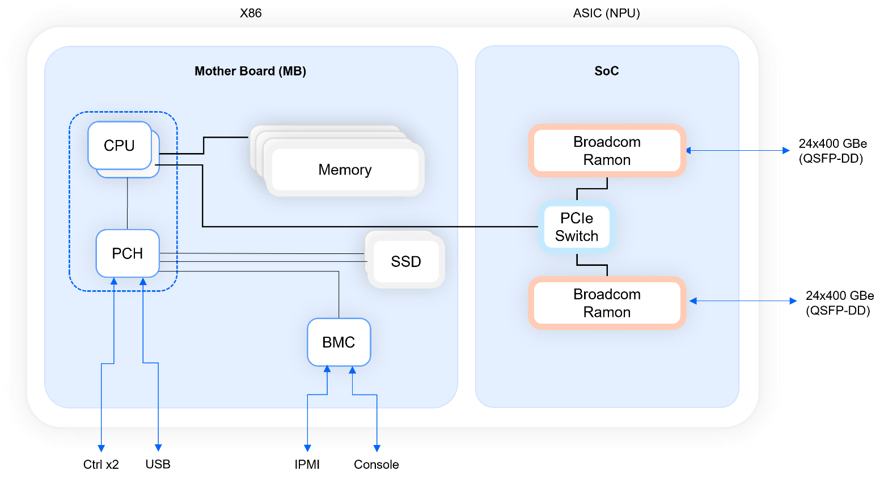

#### NCF Hardware

**NCF1**

NCF1

-

NCF

-

48

CD

*UfiSpace S9705-48D*

•

Disaggregated Open Router (DOR)

•

Distributed Disaggregated Chassis (DDC) “fabric card”

white box

•

x 400GE QSFP-DD fabric ports

48

•

1

x RJ45 + micro-USB serial console port

•

1

x 1GBase-T Ethernet port for out-of-band management

•

1

x USB 2.0 Type-A general purpose port

•

2

x 10GBase-X SFP+ management ports

•

Broadcom Ramon silicon

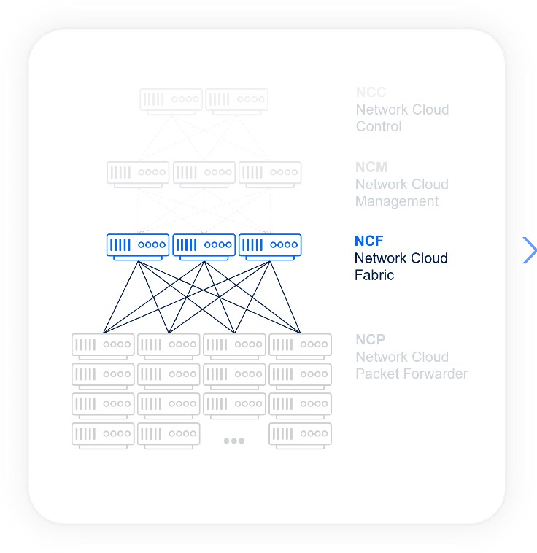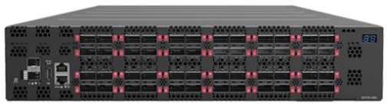

[Link to manufacturer sit](https://www.ufispace.com/products/telco/core-edge/s9705-48d-400g-disaggregated-core-router)

[e](https://www.ufispace.com/products/telco/core-edge/s9705-48d-400g-disaggregated-core-router)

## NCP: Network Cloud Packet Forwarder

The NCP is a carrier-grade, high-rate forwarding element responsible for datapath traffic forwarding.

**NCP Hardware Designs**

##### NCP Light

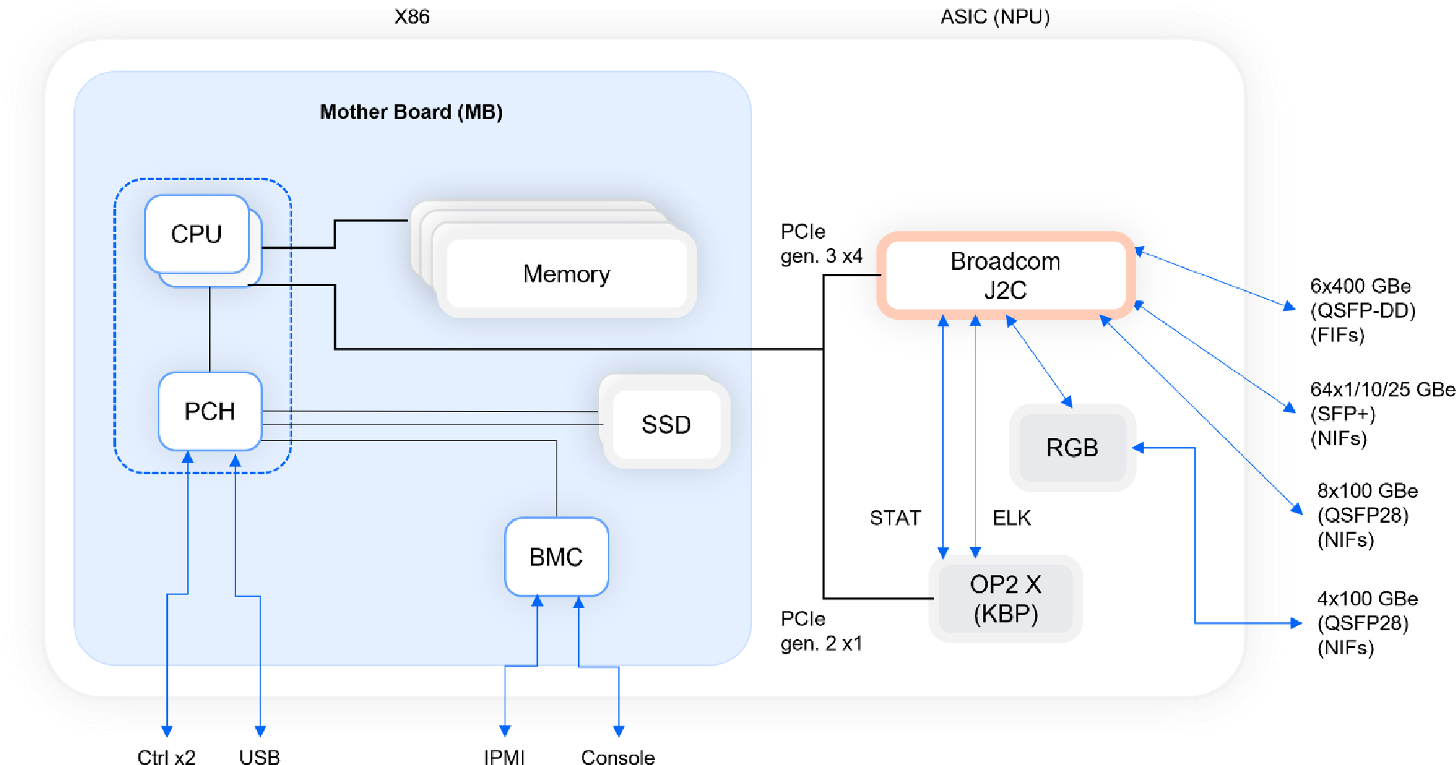

##### NCP1

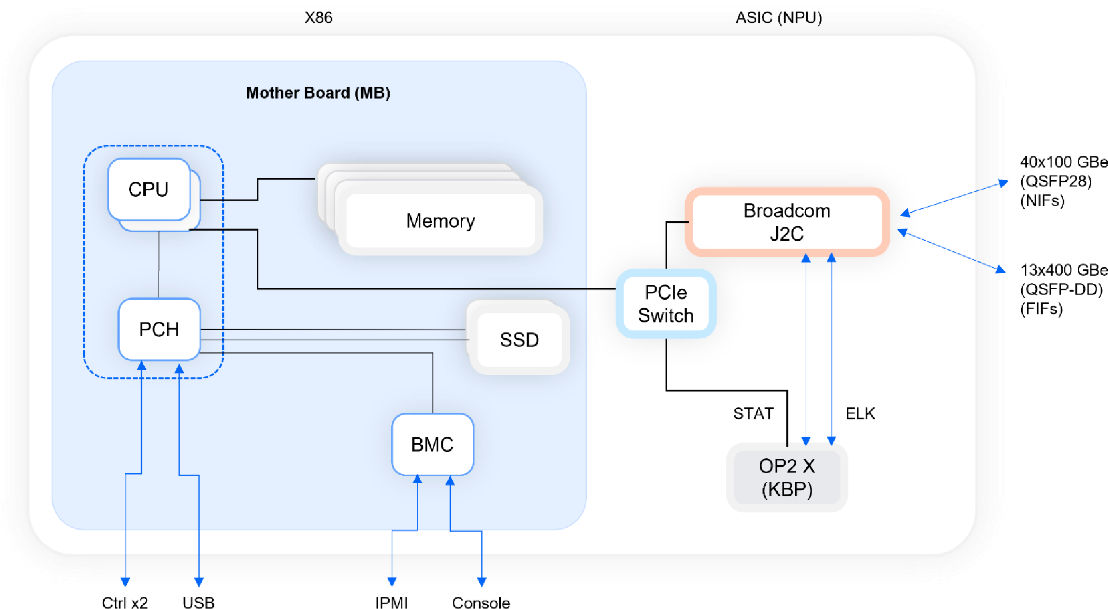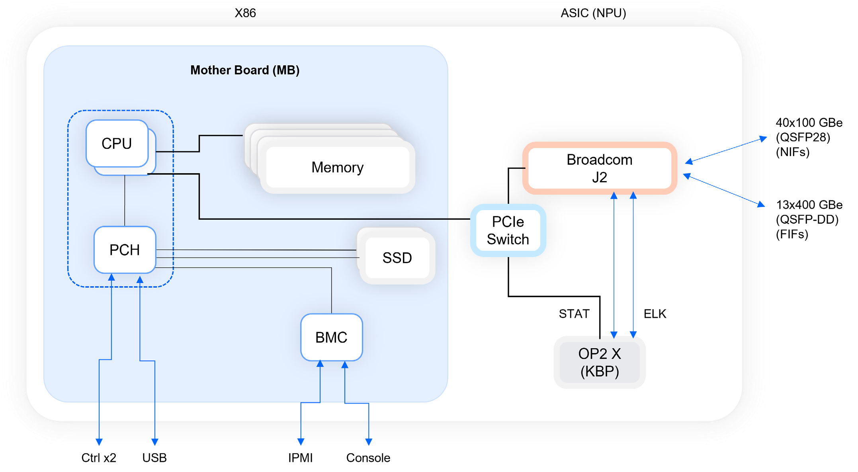

##### NCP2

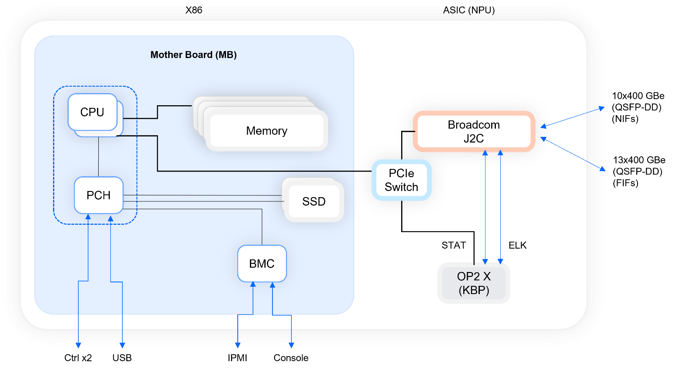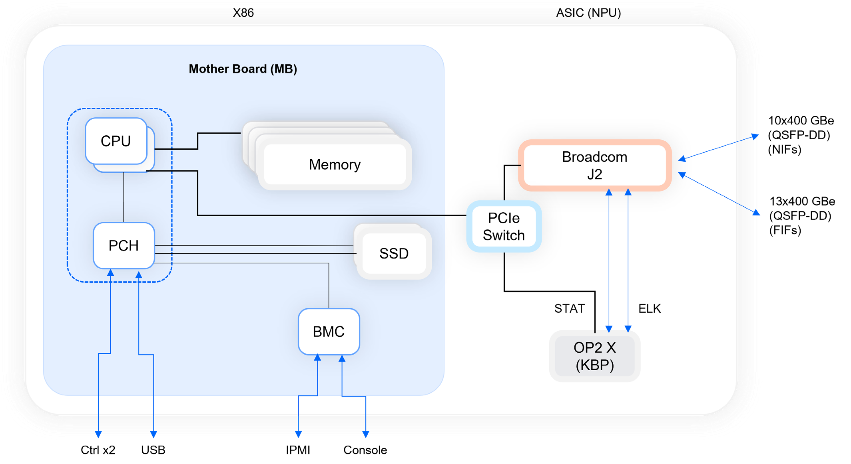

##### NCP3

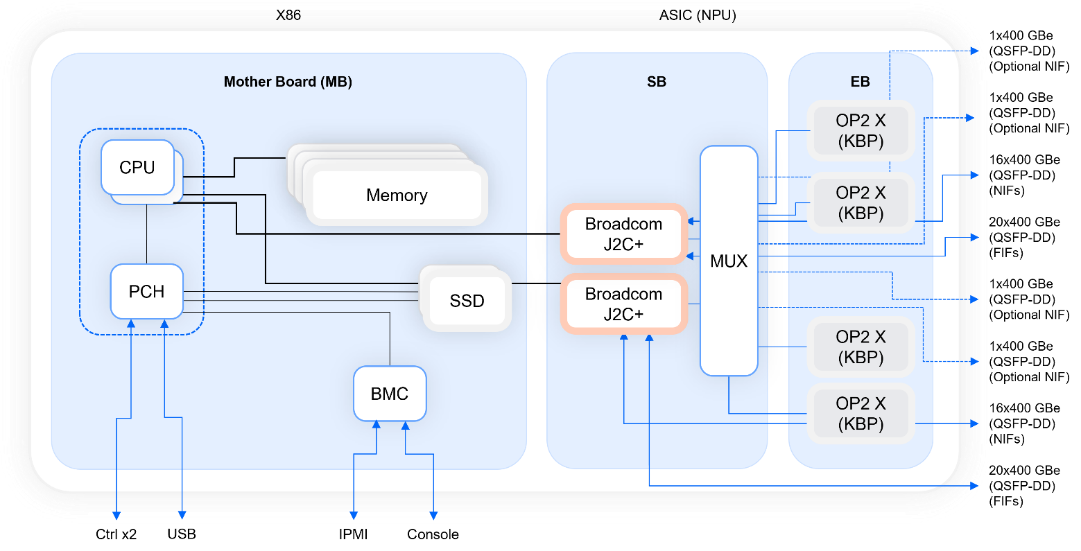

#### NCP Hardware Variations

**NCP1**

[o](https://www.ufispace.com/products/telco/core-edge/s9700-53dx-100g-core-router)

[Link t](https://www.ufispace.com/products/telco/core-edge/s9700-53dx-100g-core-router)

[manufacturer sit](https://www.ufispace.com/products/telco/core-edge/s9700-53dx-100g-core-router)

[e](https://www.ufispace.com/products/telco/core-edge/s9700-53dx-100g-core-router)

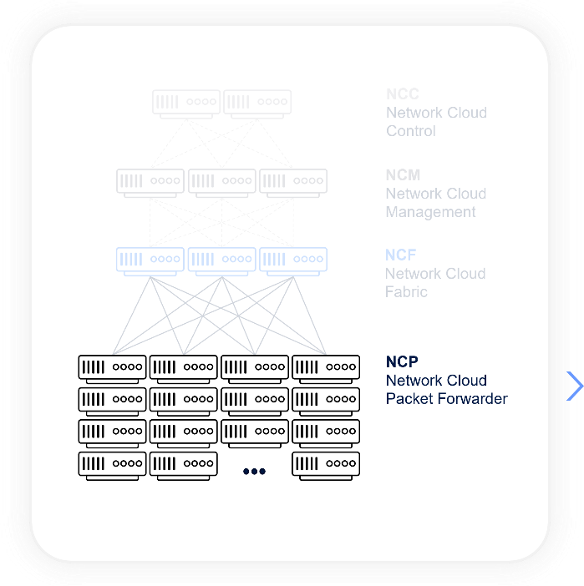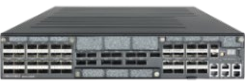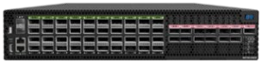

NCP1

-

NCP

-

40

C

*COR550*

*-*

*AS7926*

*-*

*XKFB*

*40*

•

x 100GE QSFP28 service ports

40

•

13

x 400GE QSFP-DD fabric ports

•

1

x RJ45 + micro-USB serial console port

•

1

x 1GBase-T Ethernet port for out-of-band management

•

1

x USB 2.0 Type-A general purpose port

•

2

x 10GBase-X SFP+ management ports

•

Broadcom J2 chipset

[o](https://www.edge-core.com/productsInfo.php?cls=291&cls2=543&cls3=548&id=851)

[Link t](https://www.edge-core.com/productsInfo.php?cls=291&cls2=543&cls3=548&id=851)

[e](https://www.edge-core.com/productsInfo.php?cls=291&cls2=543&cls3=548&id=851)

[manufacturer sit](https://www.edge-core.com/productsInfo.php?cls=291&cls2=543&cls3=548&id=851)

NCP1

-

NCP

-

C

40

*S9700-53DX*

**NCP**

2

NCP2

-

NCP

-

10

CD

*S9700-23D*

•

10

x 400GE QSFP-DD service ports

•

x 400GE QSFP-DD fabric ports

13

•

x RJ45 + micro-USB serial console port

1

•

1

x 1GBase-T Ethernet port for out-of-band management

•

1

x USB 2.0 Type-A general purpose port

•

2

x 10GBase-X SFP+ management ports

•

Broadcom J2 chipset

[Link to manufacturer sit](https://www.ufispace.com/products/telco/core-edge/s9700-23d-400g-disaggregated-core-router)

[e](https://www.ufispace.com/products/telco/core-edge/s9700-23d-400g-disaggregated-core-router)

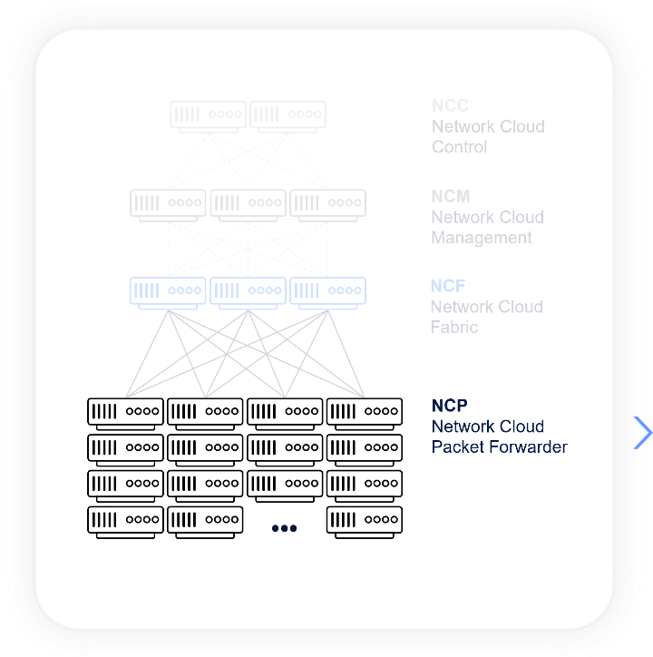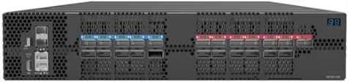

**NCP3**

NCP3

-

NCP

-

CD

36

-

S

*S9710-76D*

•

x 400GE QSFP-DD service ports

36

•

x 400GE QSFP-DD fabric ports

40

•

x RJ45 + micro-USB serial console port

1

•

x 1GBase-T Ethernet port for out-of-band management

1

•

x USB 3.0 Type-A general purpose port

1

•

x 10GBase-X SFP+ management ports

2

•

Broadcom J2c+ silicon

[Link to manufacturer sit](https://www.ufispace.com/products/telco/core-edge/s9710-76d-high-density-400g-disaggregated-core-router)

[e](https://www.ufispace.com/products/telco/core-edge/s9710-76d-high-density-400g-disaggregated-core-router)

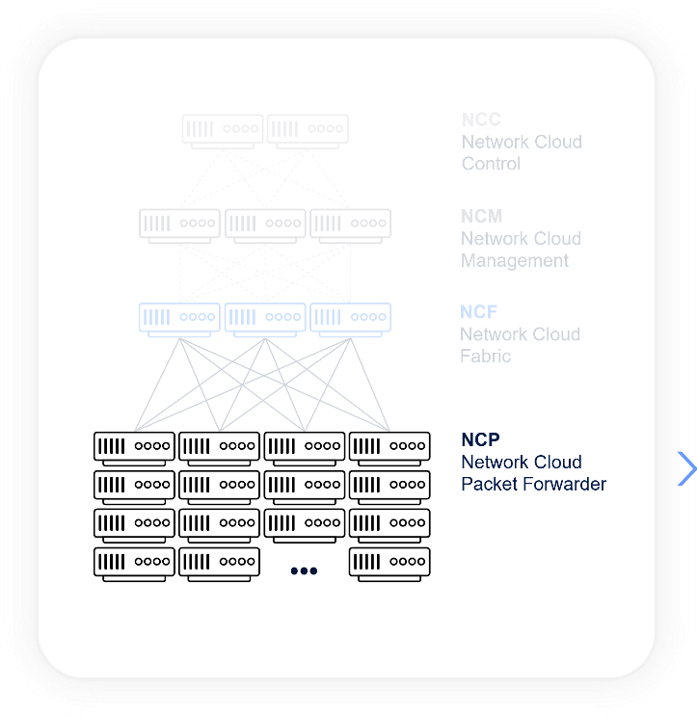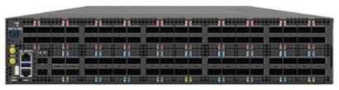

**NCP**

Light

NCP Light

-

NCP

-

X12C

64

-

S

*S9701-82DC*

•

x 25GE SFP28 service ports

64

•

x 100GE QSFP28 service ports

12

•

6

x 400GE QSFP-DD fabric ports

•

1

x RJ45 + micro-USB serial console port

•

1

x 10/100/1000M RJ45 management port

•

1

x USB 3.0 Type-A general purpose port

•

2

x 10GBase-X SFP+ management ports

•

Broadcom J2c silicon

[Link to manufacturer sit](https://www.ufispace.com/products/telco/core-edge/s9701-82dc-high-density-25g-open-edge-core-router)

[e](https://www.ufispace.com/products/telco/core-edge/s9701-82dc-high-density-25g-open-edge-core-router)

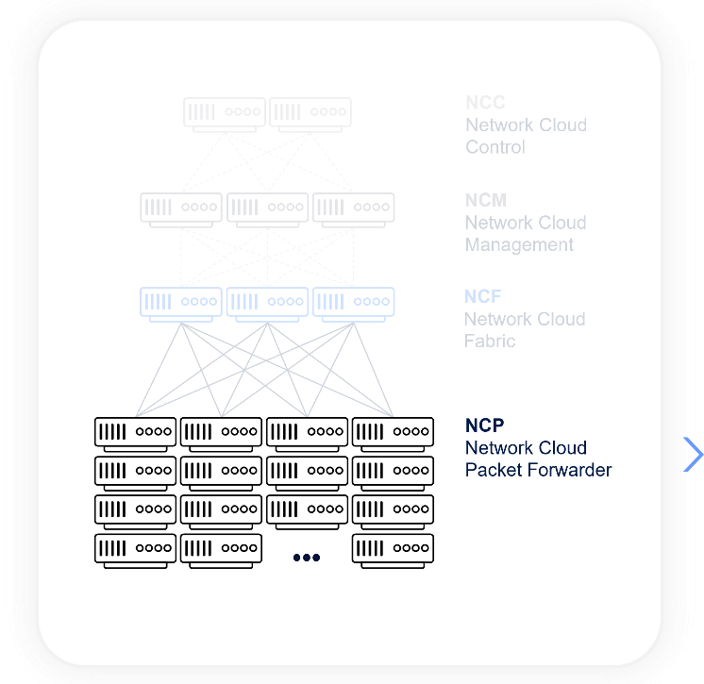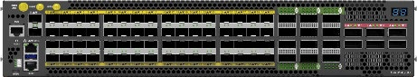

## Summary

The following tables summarize the main specifications of the currently certified white boxes and servers.

|  |  |  |  |  |  |  |  |  |  |  |
| --- | --- | --- | --- | --- | --- | --- | --- | --- | --- | --- |
| **Element** | **Description** | **DriveNets Model** | **Manufacturer** | **ODM Model** | **ASIC** |  | **Network Interfaces** | | | **More**  **Info** |
| **10GE** | **25GE** | **100GE** | **400GE** |
| NCM | Aggregation Router | NCM-48X-6C | Edgecore | AS5916-54XL | Broadcom Qumran MX | 48 | - | 6 | - | [Link](https://www.edge-core.com/productsInfo.php?cls=291&cls2=327&cls3=328&id=771) |
| NCF1 | DDC “Fabric Card” white box | NCF-48CD | UfiSpace | S9705-48D | Broadcom Ramon | - | - | - | 48 FIF | [Link](https://www.ufispace.com/products/telco/core-edge/s9705-48d-400g-disaggregated-core-router) |
| NCP1 | DDC “Line Card” white box | NCP-40C | UfiSpace | S9700-53DX | Broadcom J2 | - | - | 40 NIF | 13 FIF | [Link](https://www.ufispace.com/products/telco/core-edge/s9700-53dx-100g-core-router) |
| NCP1 | DDC “Line Card” white box | NCP-40C | Edgecore | AS7926-40XKFB | Broadcom J2 | - | - | 40 NIF | 13 FIF | [Link](https://www.edge-core.com/productsInfo.php?cls=291&cls2=543&cls3=548&id=851) |
| NCP2 | DDC “Line Card” white box | NCP-10CD | UfiSpace | S9700-23D | Broadcom J2 | - | -  - | - | 13FIF  10 NIF | [Link](https://www.ufispace.com/products/telco/core-edge/s9700-53dx-100g-core-router) |
| NCP3 | DDC “Line Card” white box | NCP-36CD-S | UfiSpace | S9710-76D | Broadcom J2C+ | - | -  - | - | 40 FIF  36 NIF | [Link](https://www.ufispace.com/products/telco/core-edge/s9710-76d-high-density-400g-disaggregated-core-router) |
| NCP Light | DDC “Line Card” white box | NCP-64X12C-S | UfiSpace | S9701-82DC | Broadcom J2C | - | 64 NIF | 12 NIF | 6 FIF | [Link](https://www.ufispace.com/products/telco/core-edge/s9701-82dc-high-density-25g-open-edge-core-router) |

|  |  |  |  |  |  |
| --- | --- | --- | --- | --- | --- |
| **Element** | **Description** | **DriveNets Model** | **ODM Model** | **More Info** | **Supported NIC** |
| NCC | Server | HPE | ProLiant DL360 Gen10 Server | [Link to Product](https://buy.hpe.com/us/en/servers/proliant-dl-servers/proliant-dl300-servers/proliant-dl360-server/hpe-proliant-dl360-gen10-server/p/1010007891) | [NVIDIA Mellanox ConnectX-5](https://www.nvidia.com/en-us/networking/ethernet/connectx-5/) [HPE InfiniBand EDR/Ethernet Adapter](https://buy.hpe.com/us/en/options/adapters/host-adapters/proliant-host-adapters/hpe-infiniband-edr-ethernet-100gb-2-port-841qsfp28-adapter/p/872726-b21) |
| NCC | Server | HPE | ProLiant DL380 Gen10 Server | [Link to Product](https://buy.hpe.com/us/en/servers/proliant-dl-servers/proliant-dl300-servers/proliant-dl380-server/hpe-proliant-dl380-gen10-server/p/1010026818) | [NVIDIA Mellanox ConnectX-5](https://www.nvidia.com/en-us/networking/ethernet/connectx-5/) [HPE InfiniBand EDR/Ethernet Adapter](https://buy.hpe.com/us/en/options/adapters/host-adapters/proliant-host-adapters/hpe-infiniband-edr-ethernet-100gb-2-port-841qsfp28-adapter/p/872726-b21) |
| NCC | Server | Dell | EMC PowerEdge R640 | Link to Product | [NVIDIA Mellanox ConnectX-5](https://www.nvidia.com/en-us/networking/ethernet/connectx-5/) |
| NCC | Server | Dell | EMC PowerEdge R740 | Link to Product | [NVIDIA Mellanox ConnectX-5](https://www.nvidia.com/en-us/networking/ethernet/connectx-5/) |

# Additional Components

## Cables and Transceivers

DriveNets Network Cloud solution is built in a disaggregated manner, similar to hyperscalers’ clouds. As stated previously, Network Cloud supports two models – stand-alone or cluster – both of which are based on standard white boxes using merchant silicon. Made up of dozens of white boxes that function as a single routing entity, the cluster-based model can scale up to 691.2 Tbps.

These white boxes are connected through cables from various manufacturers, including active optical cable (AOC), direct access cable (DAC), and active electrical cable (AEC). DriveNets supports a full range of copper cables and optical transceivers, compliant with IEEE standards, for the networkfacing interfaces on NCP white boxes. These cables and transceivers are available in different fiber types and reach requirements, ranging from 1G to 400G.

Please note that DriveNets does not manufacture cables or optics. Instead, it supports third-party products from various vendors that are qualified by the white box original device manufacturer (ODM) and/or DriveNets.

## DriveNets Optics and Cables Qualification Process

The DriveNets qualification process for optical modules and cables is based on the following guidelines:

* Fabric interfaces: All fabric-related cables and optics are tested by DriveNets. The type and vendor of a given optical module may have significant impact on the performance and quality of the internal cluster interconnection (NCF to NCP). DriveNets tests these cables/optics on top of the ODM certification process to assure the highest performance of delivered solutions.
* Network interface: DriveNets qualifies a single type of each optical module (e.g. 100G SR and 100G LR) on each certified white box. DriveNets usually tests one or two vendors per type. The DriveNets solution is agnostic to products supplied by other optic vendors using the same speed and type, provided that they have been approved by the hardware ODM.
* Control interfaces: All new control interface transceivers are tested by DriveNets, on both sides of the control lane.
* Management interfaces: All new management interface transceivers are tested by DriveNets.

## Supported Optics and Cables

The most current information on DriveNets-qualified cables and transceivers can be found on the [DriveNets documentation portal,](https://docs.drivenets.com/) which is regularly updated by the DriveNets team. This is the preferred method for obtaining up-to-date information. However, here is a sample list of supported cables and optics: **Cables:**

|  |  |  |  |  |  |  |  |
| --- | --- | --- | --- | --- | --- | --- | --- |
| **Data Rate** | **Length** | **Breakout** | **AEC** |  | **AOC** |  | **DAC** |
| **100G** | 0.5m-1m |  |  |  |  |  | ✓ |
| 7m |  |  | ✓ |  | ✓ |  |
| **400G** | 0.5m |  |  | ✓ |  |  |  |
| 1.5m |  |  |  |  |  | ✓ |
| 10m |  |  |  |  | ✓ |  |
| 1m |  |  | ✓ |  |  | ✓ |
| 2.5m |  |  | ✓ |  |  |  |
| 2m |  |  | ✓ |  |  |  |
| 3m |  |  | ✓ |  |  |  |
| 5m |  |  | ✓ |  |  |  |
| **40G (4X10G)** | 3m | ✓ |  |  |  |  |  |

**Optical Transceivers:**

|  |  |  |  |  |
| --- | --- | --- | --- | --- |
| **Data Rate** | **Type & Length** | **Network Interface** | **Fabric** | **Control** |
| **100G** | CWDM4 – 2km | ✓ |  | ✓ |
| DR1 - 500m | ✓ |  |  |
| ER4 – 40km | ✓ |  |  |
| LR4 – 10km | ✓ |  | ✓ |
| SR4 - 100m | ✓ |  | ✓ |
| ZR4 – 100km | ✓ |  |  |
| **10G** | LR - 10Km | ✓ |  | ✓ |
| SR - 400m |  |  | ✓ |
| **1G** | 1000BASE-T - 100m |  |  | ✓ |
| **400G** | FR4 – 2km | ✓ | ✓ |  |
| **400G (4X100)** | DR4 - 500m | ✓ |  |  |
| DR4+ - 2km | ✓ |  |  |
| LR4 – 10km | ✓ |  |  |
| **40G (4X10G)** | LR – 10km | ✓ |  |  |

DriveNets is a leader in cloud-native networking software and network disaggregation solutions. Founded

in 2015 and based in Israel, DriveNets offers service providers and cloud providers a radical new way to

build

networks,

substantially growing their profitability by changing their technological and

economic models. DriveNets’ solution

– Network Cloud – adapts the architectural model of cloud to

telco-grade networking. Network Cloud is a cloud-native software that runs over a shared physical

infrastructure of standard white-boxes, radically simplifying the network’s operations, offering telco-

scale performance and elasticity at a much lower cost.

For more information, visit us at

[**www.drivenets.co**](http://www.drivenets.com/)

[**m**](http://www.drivenets.com/)

